Read Text Extension on Ubuntu with LibreOffice
https://sites.google.com/site/readtextextension/home/linux

Linux
Select a speech synthesis tool, then install it following the instructions below. For English, French, Italian, German and Spanish, SVOX Pico is a good choice. For Catalan, Czech, Finnish, Hindi, Marathi, Russian and Telugu, festival is recommended. You can use espeak to read many other languages as well.

Get the extension at the Extensions web site.

http://extensions.libreoffice.org/extension-center/read-text

Open the extension with the LibreOffice or Apache OpenOffice program. Approve the extension. Restart the program.

Pico

The Pico speech synthesizer speaks clearly and is simple to use. The pico speech description files are in binary format only, so unlike espeak, you can't edit the speech rules for localized pronunciation of particular words or place names. The SVOX Pico speech synthesizer uses Hidden Markov Model (HMM) algorithms to produce clear speech output in the form of an audio file. It works with German, English, Spanish, French and Italian text. Read Text Extension now includes a python script to read the SVOX Pico audio file aloud using an audio or movie player.
- The SVOX Pico speech synthesizer packages are available in Debian's non-free repository and in Ubuntu's multiverse repository. Use a package manager like Synaptic or apt-get to install the following packages:
  - libttspico0
  - libttspico-utils
  - libttspico-data
- If you want to try it with Linux, and your distribution includes apt-get, use these commands to install it:
sudo apt-get install libttspico0 libttspico-utils libttspico-data
- Other Linux distributions may make the SVOX Pico packages available with a different name. You need an up-to-date version of the Read Text Extension. Once you have installed the software, set up Read Text Extension's options with Tools - Add-ons - Read selection.... Use /usr/bin/python as the external program. Select a command line option that includes the token (PICO_READ_TEXT_PY).

Soy Wachín, yo le puse esto:
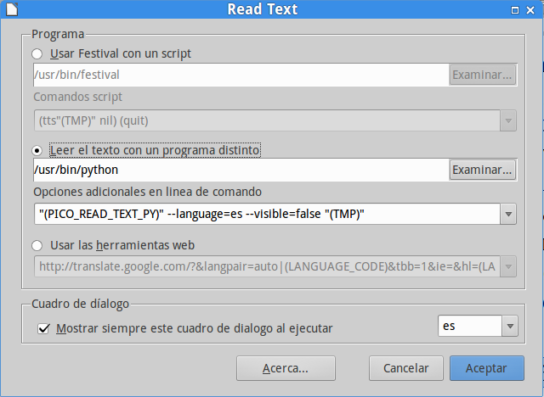

También le puse así:

"(PICO_READ_TEXT_PY)" --language=(SELECTION_LANGUAGE_COUNTRY_CODE) --rate=75% --pitch=100% --visible=false "(TMP)"

